Universal Robots: Arm Programs and Supporting Documentation

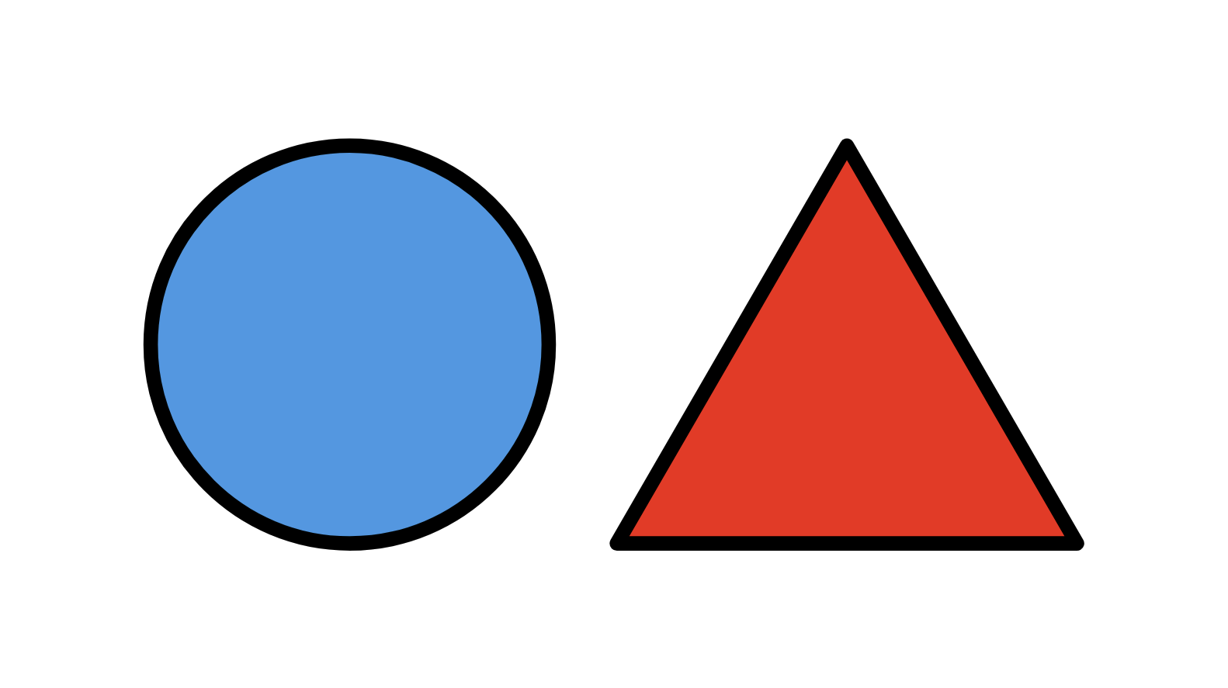

ME500: Advanced Manufacturing
Spring 2026
Variable Product Manufacturing (Thursday PM Lab Group)
Chris Daub, Riley Hubscher, Mukhamed Kerimkul, Bramasto Prasojo, and Chaitanya Sai Nikith Rambha

Table of Contents
Overview 4
Admin Programs 4
Custom Programs for Variable Product Manufacturing 5
Appendix A: URP Script Descriptions 7
Rosie Admin Programs 7
_adminCG-ConveyorToPHome.urp 7
_adminCG-invAToPHome.urp 7
_adminCG-invBToPHome.urp 7
_adminCG-invCToPHome.urp 7
_adminCG-invDToPHome.urp 7
_adminCG-PHomeToConveyor.urp 7
_adminCG-PHomeToInvA.urp 7
_adminCG-PHomeToInvB.urp 7
_adminCG-PHomeToInvC.urp 8
_adminCG-PHomeToInvD.urp 8
_adminLinearIndex1.urp 8
_adminLinearIndex3.urp 8
_adminLinearIndex4.urp 8
Rosie Custom Programs 8
Assembly_Vision.urp 8
vision_pc_modbus.script 8
hookA_manager.urp 9
hookB_manager.urp 9
Short_LidToCamera 9
Tall_LidToCamera 9
Mary Admin Programs 9
_adminCG-ConveyorToPHome.urp 9
_adminCG-invAToPHome.urp 9
_adminCG-invCToPHome.urp 9
_adminCG-PHomeToConveyor.urp 9
_adminCG-PHomeToInvA.urp 10
_adminCG-PHomeToInvC.urp 10
_adminLinearIndex1.urp 10
_adminLinearIndex3.urp 10
_adminLinearIndex5.urp 10
Mary Custom Programs 10
gravityFeederT.urp 10
Tall_PHomeToInvC.urp 10
Tall_StockT_LoadMill_MakePart_Tier3.urp 10
Tall_Lid_UnloadMill.urp 10
Short_PHomeToInvC.urp 11
Short_StockT_LoadMill_MakePart_Tier3.urp 11
Short_Lid_UnloadMill.urp 11
Edie Admin Programs 11
_adminCG-ConveyorToPHome.urp 11
_adminCG-invBToPHome.urp 11
_adminCG-invDToPHome.urp 11
_adminCG-PHomeToConveyor.urp 11
_adminCG-PHomeToInvB.urp 11
_adminCG-PHomeToInvD.urp 11
_adminLinearIndex1.urp 12
_adminLinearIndex2.urp 12
_adminLinearIndex4.urp 12
Edie Custom Programs 12
gravityFeederV.urp 12
Short_Body_UnloadMill_Tier1.urp 12
Short_PHomeToInvB.urp 12
Short_StockT_LoadMill_MakePart_Tier1.urp 12
Tall_StockT_LoadMill_MakePart_Tier3.urp 12
Tall_PHomeToInvD.urp 13
Tall_Body_UnloadMill_Tier3.urp 13

Overview
The URP files control universal robots arms codenamed “Edie”, “Mary”, and “Rosie”, which share a number of responsibilities:
- CNC mill tending
- Loading stock onto pallets and pallets onto the conveyor belt
- Shuffling pallets between inventory bays and the computer vision station
- Assembling the final product
All files have been submitted to Blackboard in a ZIP file with this document.
The list of all URP files used in Variable Product Manufacturing is as follows:

Admin Programs
The following are the default existing admin robot programs used in the project.
Rosie
- _adminCG-ConveyorToPHome.urp
- _adminCG-invAToPHome.urp
- _adminCG-invBToPHome.urp
- _adminCG-invCToPHome.urp
- _adminCG-invDToPHome.urp
- _adminCG-PHomeToConveyor.urp
- _adminCG-PHomeToInvA.urp
- _adminCG-PHomeToInvB.urp
- _adminCG-PHomeToInvC.urp
- _adminCG-PHomeToInvD.urp
- _adminLinearIndex1.urp
- _adminLinearIndex3.urp
- _adminLinearIndex4.urp
Mary
- _adminCG-ConveyorToPHome.urp
- _adminCG-InvAtoPHome.urp
- _adminCG-InvCtoPHome.urp
- _adminCG-PHomeToConveyor.urp
- _adminCG-PHomeToInvA.urp
- _adminCG-PHomeToInvC.urp
- _adminLinearIndex1.urp
- _adminLinearIndex3.urp
- _adminLinearIndex5.urp
Edie
- _adminCG-ConveyorToPHome.urp
- _adminCG-InvBToPHome.urp
- _adminCG-InvDToPHome.urp
- _adminCG-PHomeToConveyor.urp
- _adminCG-PHomeToInvB.urp
- _adminCG-PHomeToInvD.urp
- linearSlideIndex1.urp
- linearSlideIndex2.urp
- linearSlideIndex4.urp

Custom Programs for Variable Product Manufacturing
Rosie
- Assembly_Vision.urp
- Vision_pc_modbus.script
- hookA_manager.urp
- hookB_manager.urp
- Short_LidToCamera.urp
- Tall_LidToCamera.urp
Mary
- gravityFeederT.urp
- Tall_PHomeToInvC.urp
- Tall_StockT_LoadMill_MakePart_Tier3.urp
- Tall_Lid_UnloadMill.urp
- Short_PHomeToInvA.urp
- Short_StockT_LoadMill_MakePart_Tier1.urp
- Short_Lid_UnloadMill.urp
Edie
- gravityFeederV.urp
- Short_Body_UnloadMill_Tier1.urp
- Short_PHomeToInvB.urp
- Short_StockV_LoadMill_MakePart_Tier1.urp
- Tall_Body_UnloadMill_Tier3.urp
- Tall_PHomeToInvD.urp
- Tall_StockV_LoadMill_MakePart_Tier3.urp

Appendix A: URP Script Descriptions

Rosie Admin Programs

_adminCG-ConveyorToPHome.urp
Picks the pallet from conveyor and moves it to PHome

_adminCG-invAToPHome.urp
Picks the pallet from invA and moves it to PHome

_adminCG-invBToPHome.urp
Picks the pallet from invB and moves it to PHome

_adminCG-invCToPHome.urp
Picks the pallet from invC and moves it to PHome

_adminCG-invDToPHome.urp
Picks the pallet from invD and moves it to PHome

_adminCG-PHomeToConveyor.urp
Moves the pallet from PHome to Conveyor

_adminCG-PHomeToInvA.urp
Moves the pallet from PHome to InvA

_adminCG-PHomeToInvB.urp
Moves the pallet from PHome to InvB

_adminCG-PHomeToInvC.urp
Moves the pallet from PHome to InvC

_adminCG-PHomeToInvD.urp
Moves the pallet from PHome to InvD

_adminLinearIndex1.urp
Moves the Linear slider to position 1

_adminLinearIndex3.urp
Moves the Linear slider to position 3

_adminLinearIndex4.urp
Moves the Linear slider to position 4

Rosie Custom Programs

Assembly_Vision.urp
Conditional assembly program which assembles Tall or Short according to the results from vision_pc_modbus script.

vision_pc_modbus.script
Script file called in camera scan programs which runs the vision program on the computer and write the values using MODBUS

hookA_manager.urp
Using the hook_index global variable value the hooks of Short are picked accordingly during the assembly process.

hookB_manager.urp
Using the hook_indexB global variable value the hooks of Short are picked accordingly during the assembly process.

Short_LidToCamera
Gets the short lid pallet to camera scan and runs the vision_pc_modbus.script and gets the pallet back to its inventory location.

Tall_LidToCamera
Gets the tall lid pallet to camera scan and runs the vision_pc_modbus.script and gets the pallet back to its inventory location.

Mary Admin Programs

_adminCG-ConveyorToPHome.urp
Picks the pallet from the conveyor and moves it to PHome.

_adminCG-invAToPHome.urp
Picks the pallet from invA and moves it to PHome.

_adminCG-invCToPHome.urp
Picks the pallet from invC and moves it to PHome.

_adminCG-PHomeToConveyor.urp
Moves the pallet from PHome to Conveyor.

_adminCG-PHomeToInvA.urp
Moves the pallet from PHome to InvA.

_adminCG-PHomeToInvC.urp
Moves the pallet from PHome to InvC.

_adminLinearIndex1.urp
Moves the Linear slider to position 1.

_adminLinearIndex3.urp
Moves the Linear slider to position 3.

_adminLinearIndex5.urp
Moves the Linear slider to position 5.

Mary Custom Programs

gravityFeederT.urp
Collects stock T and squares it.

Tall_PHomeToInvC.urp
Gets the product Tall to InvC

Tall_StockT_LoadMill_MakePart_Tier3.urp
Loads stock T in tier 3 makes the Tall Lid.

Tall_Lid_UnloadMill.urp
Unload the Tall Lid and get it to PHome.

Short_PHomeToInvC.urp
Gets the product Short to InvC

Short_StockT_LoadMill_MakePart_Tier3.urp
Loads stock T in tier 3 makes the Short Lid.

Short_Lid_UnloadMill.urp
Unload the Short Lid and transports it to PHome.

Edie Admin Programs

_adminCG-ConveyorToPHome.urp
Picks the pallet from the conveyor and moves it to PHome.

_adminCG-invBToPHome.urp
Picks the pallet from invB and moves it to PHome.

_adminCG-invDToPHome.urp
Picks the pallet from invD and moves it to PHome.

_adminCG-PHomeToConveyor.urp
Moves the pallet from PHome to Conveyor.

_adminCG-PHomeToInvB.urp
Moves the pallet from PHome to InvB.

_adminCG-PHomeToInvD.urp
Moves the pallet from PHome to InvD.

_adminLinearIndex1.urp
Moves the Linear slider to position 1.

_adminLinearIndex2.urp
Moves the Linear slider to position 2.

_adminLinearIndex4.urp
Moves the Linear slider to position 4.

Edie Custom Programs

gravityFeederV.urp
Collects stock V and squares it.

Short_Body_UnloadMill_Tier1.urp
Unload the Short Body and get it to PHome.

Short_PHomeToInvB.urp
Gets the product Short to InvB

Short_StockT_LoadMill_MakePart_Tier1.urp
Loads stock T in tier 3 makes the Short Body.

Tall_StockT_LoadMill_MakePart_Tier3.urp
Loads stock T in tier 3 makes the Tall Lid.

Tall_PHomeToInvD.urp
Gets the product Tall to InvD

Tall_Body_UnloadMill_Tier3.urp
Unload the Tall Body and transports it to PHome.

